Experiment – 19
Implementation of Naive Bayes classification for Bank Loan prediction.

Aim:
To predict whether a loan application will be Approved or Rejected using the Gaussian Naïve Bayes algorithm on five different loan datasets.

Algorithm:

- Import GaussianNB, train_test_split, and accuracy_score.
- Create the five given loan datasets.
- Separate each dataset into input features X and target labels y.
- Split the data into training and testing sets.
- Create a Gaussian Naïve Bayes model.
- Train the model using the training data.
- Predict the loan status of the test data.
- Calculate the model accuracy.
- Predict the loan status of the given new sample.
- Display the prediction and accuracy for all five datasets.

Program:
import numpy as np
import pandas as pd
from sklearn.naive_bayes import GaussianNB
from sklearn.model_selection import train_test_split
from sklearn.metrics import accuracy_score
def naive_bayes_prediction(dataset_name, X, y, new_sample):
print("\n" + "=" * 70)
print(dataset_name)
print("=" * 70)
# Step 1: Split the dataset
X_train, X_test, y_train, y_test = train_test_split(
X,
y,
test_size=0.3,
random_state=42,
stratify=y
)
# Step 2: Create Gaussian Naive Bayes model
model = GaussianNB()

# Step 3: Train the model
model.fit(X_train, y_train)

# Step 4: Predict test data
y_pred = model.predict(X_test)

# Step 5: Calculate accuracy
accuracy = accuracy_score(y_test, y_pred)

# Step 6: Predict new sample
prediction = model.predict(new_sample)

# Display results
print("Test Accuracy:", round(accuracy * 100, 2), "%")
print("Predicted Loan Status:", prediction[0])

return accuracy, prediction[0]
X1 = np.array([
[12, 820, 5],
[10, 790, 6],
[9, 760, 7],
[7, 700, 8],
[6, 680, 9],
[5, 650, 10],
[4, 620, 12],
[8, 730, 8],
[3, 600, 13],
[11, 810, 5]
])

y1 = np.array([
"Approved",
"Approved",
"Approved",
"Approved",
"Rejected",
"Rejected",
"Rejected",
"Approved",
"Rejected",
"Approved"
])
new1 = np.array([[9, 770, 6]])
accuracy1, prediction1 = naive_bayes_prediction(
"DATASET 1: PERSONAL LOAN APPROVAL",
X1, y1, new1
)
X2 = np.array([
[90000, 850, 8000],
[80000, 820, 9000],
[70000, 780, 12000],
[60000, 740, 15000],
[50000, 690, 18000],
[45000, 670, 20000],
[40000, 640, 23000],
[75000, 800, 10000],
[35000, 620, 25000],
[95000, 870, 7000]
])

y2 = np.array([
"Approved",
"Approved",
"Approved",
"Approved",
"Rejected",
"Rejected",
"Rejected",
"Approved",
"Rejected",
"Approved"
])

# New sample
new2 = np.array([[72000, 790, 11000]])

accuracy2, prediction2 = naive_bayes_prediction(
"DATASET 2: HOME LOAN APPROVAL",
X2, y2, new2
)

# ============================================================
# DATASET 3: BUSINESS LOAN APPROVAL
# ============================================================

# Features:
# Business Income, Business Age, Existing Loans

X3 = np.array([
[20, 10, 1],
[18, 9, 1],
[15, 8, 2],
[12, 6, 2],
[10, 5, 3],
[8, 4, 3],
[6, 3, 4],
[16, 8, 2],
[5, 2, 5],
[22, 12, 1]
])

y3 = np.array([
"Approved",
"Approved",
"Approved",
"Approved",
"Rejected",
"Rejected",
"Rejected",
"Approved",
"Rejected",
"Approved"
])

# New sample
new3 = np.array([[17, 8, 2]])

accuracy3, prediction3 = naive_bayes_prediction(
"DATASET 3: BUSINESS LOAN APPROVAL",
X3, y3, new3
)
X4 = np.array([
[15, 92, 6],
[13, 89, 7],
[11, 85, 8],
[9, 80, 9],
[7, 72, 10],
[6, 68, 11],
[5, 65, 12],
[12, 87, 7],
[4, 60, 13],
[16, 94, 5]
])

y4 = np.array([
"Approved",
"Approved",
"Approved",
"Approved",
"Rejected",
"Rejected",
"Rejected",
"Approved",
"Rejected",
"Approved"
])

# New sample
new4 = np.array([[12, 88, 7]])

accuracy4, prediction4 = naive_bayes_prediction(
"DATASET 4: EDUCATION LOAN APPROVAL",
X4, y4, new4
)
# Features:
# Annual Income, Down Payment, Credit Score

X5 = np.array([
[14, 3.0, 830],
[12, 2.5, 810],
[10, 2.0, 780],
[8, 1.8, 740],
[7, 1.5, 690],
[6, 1.2, 660],
[5, 1.0, 630],
[11, 2.2, 790],
[4, 0.8, 600],
[15, 3.5, 850]
])

y5 = np.array([
"Approved",
"Approved",
"Approved",
"Approved",
"Rejected",
"Rejected",
"Rejected",
"Approved",
"Rejected",
"Approved"
])

# New sample
new5 = np.array([[11, 2.4, 800]])
accuracy5, prediction5 = naive_bayes_prediction(
"DATASET 5: VEHICLE LOAN APPROVAL",
X5, y5, new5
)
results = pd.DataFrame({
"Dataset": [
"Personal Loan",
"Home Loan",
"Business Loan",
"Education Loan",
"Vehicle Loan"
],

"Accuracy (%)": [
accuracy1 * 100,
accuracy2 * 100,
accuracy3 * 100,
accuracy4 * 100,
accuracy5 * 100
],
"New Sample Prediction": [
prediction1,
prediction2,
prediction3,
prediction4,
prediction5
]
})
results["Accuracy (%)"] = results["Accuracy (%)"].round(2)
print("\n\n")
print("=" * 70)
print("FINAL NAIVE BAYES RESULTS")
print("=" * 70)
print(results.to_string(index=False))
Output:
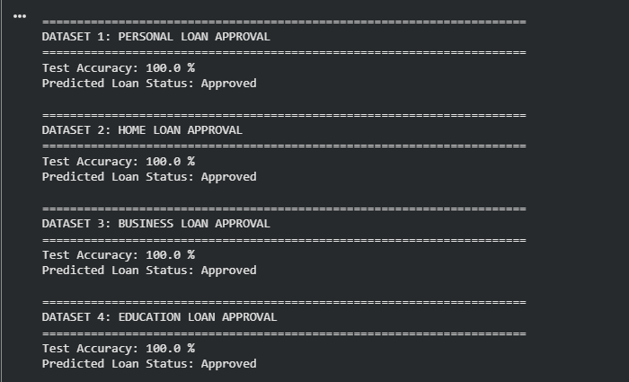
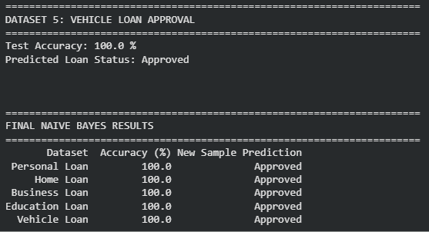

Result:
The Gaussian Naïve Bayes algorithm was successfully implemented for all five loan approval datasets. The trained models predict that all five given new applicants are Approved.

